**CMSC 436 / 636: Data Visualization**

**Assignment 2: Analysis of two Data Visualization Examples**

**Instructor: Jian Chen**

**Student: Hao Chen**

# **Analysis of two Data Visualization Examples**

A Good Example Of Data Visualization

There are many data visualization designs and techniques. One of the most important data visualization design rule is to show the real data features to the audiances. Here is a visualization example following to rule and make the feature even more obvious for user to obtain. The paper named *Bristle Maps: A Multivariate Abstraction Technique for Geovisualization*, is a good example of the data visualization technique.

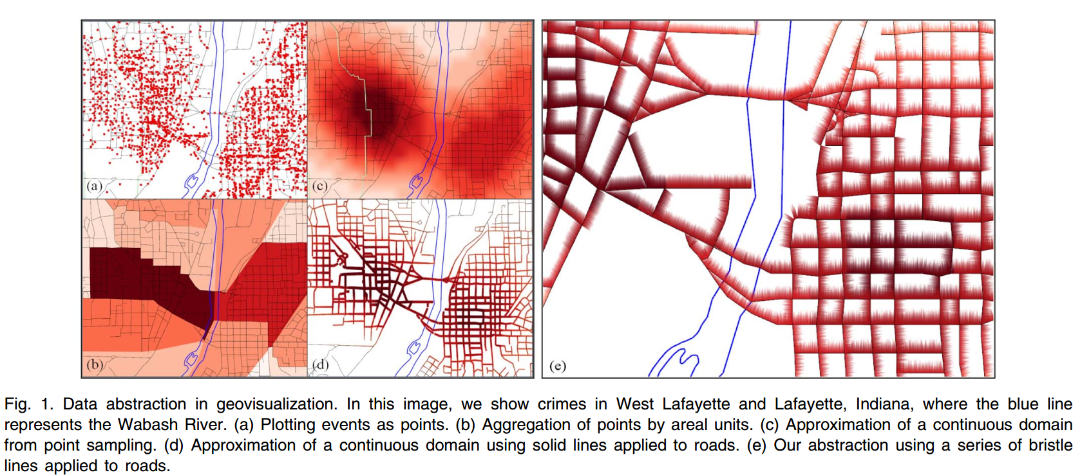

Figure 1

As the authors mentioned, “We present Bristle Maps, a novel method for the aggregation, abstraction, and stylization of spatiotemporal data that enables multiattribute visualization, exploration, and analysis”. [1]In this paper, it compared point map, KED map, Line-T and bristle maps. The result is shown below in table 1. And we can easily tell that bristle map is every effective and efficient for some tasks with good accuracy and responsible time. So the crime in Geo-location visualization, bristle map is innovative and functioning well. It can be one of the good examples of data visualization.

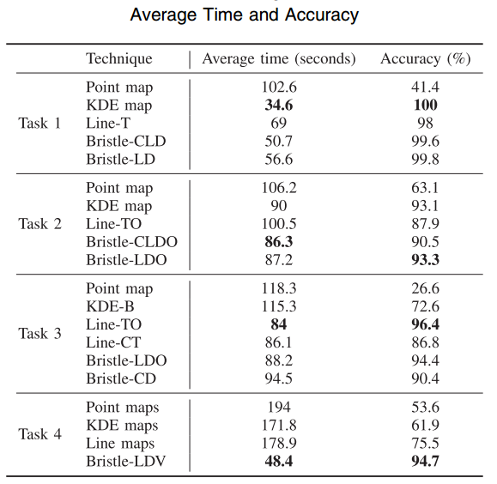

Table 1

A “misleading” Example Of Data Visualization

In the paper of *How to Display Group Information on Node-Link Diagrams: An Evaluation*, there is figure to compare all the node-link visualization strategies, which is shown here as figure 2. Since data visualization should tell the true story of the data topographies and features, the missing out or adding a part of any data could mislead the viewer to make the proper decision. In figure 2, the right down corner view is called *BubbleSets*, which I think there is a problem with it.

And in this paper it discussed how these visualization techniques could perform based on certain tasks. However, I noticed in *BubbleSets* view there is no link in the circle I drew in red, but there is a bubble linking them together. As we all can see that the other three view do not provide any node-links or connection for those two nodes. It means the *BubbleSets* view provided information more than it should, and misleading the viewers to believe there is a path between them.

In these paper, they never mentioned this problem. So their conclusion seems to be sound and solid, but because of this misleading visualization, I do not fully believe their results.

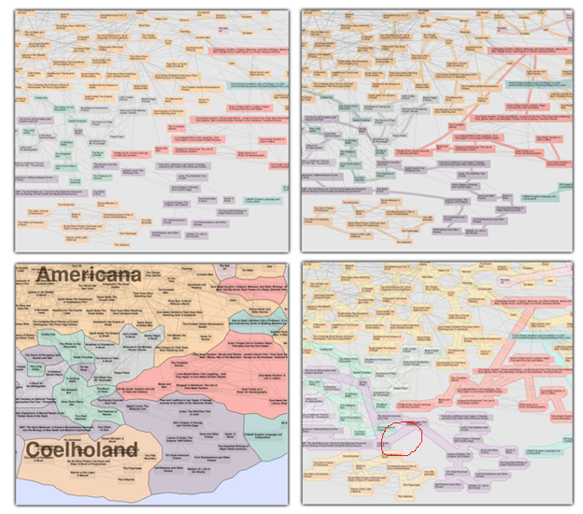

Figure 2

References:

[1] S. Kim, R. Maciejewski, A. Malik, etc. “Bristle Maps: A Multivariate Abstraction Technique for Geovisualization,” IEEE Trans. Visualization and Computer Graphic, VOL. 19, NO. 9, pp. 1438-1454, Sep. 2013

[2]R. Jianu, A Rusu, Y. Hu and D. Taggart, “How to Display Group Information on Node-Link Diagrams: An Evaluation,” IEEE Trans. Visualization and Computer Graphic, VOL. 20, NO. 11, pp. 1530-1541, Nov. 2014